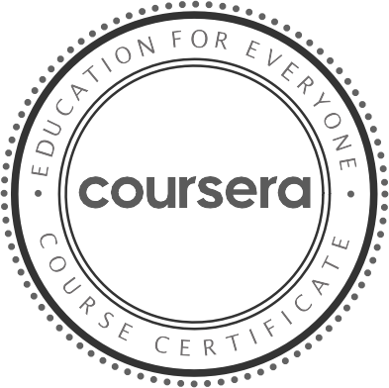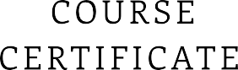

## M a y 13 , 2022

Rajesh R

# has successfully completed

Programming for Everybody ( Getting Started with Python)

# an online non-credit course authorized by University of Michigan and offered through Coursera

Charles Severance

Clinical Professor, School of Information University of Michigan

Verify at: <https://coursera.org/verify/TFS2AYJ3HXHQ>

Cour se r a ha s confir me d the ide ntity of this individua l a nd the ir

pa r t icipa t ion in the cour se .